Smart Property Management System
Phase 2 — System Design & Module Design

3. System Design
3.1 Architectural Design
The system adopts a four-tier layered architecture consistent with established software engineering practice (presentation, application, domain, persistence). Each tier depends only on the tier immediately below, satisfying the Dependency Inversion Principle and enabling independent testing and replacement.
Tier | Responsibility | Technology
Presentation | Render UI, capture user events | PySide6 (Qt for Python)
Application | Coordinate use-cases, validate input, enforce permissions | Python controllers
Domain | Business rules, entity behaviour, cross-entity operations | Python services
Persistence | Store and retrieve entities | SQLAlchemy ORM + SQLite
Cross-cutting | Scheduled tasks, email dispatch | APScheduler + smtplib

Component Diagram
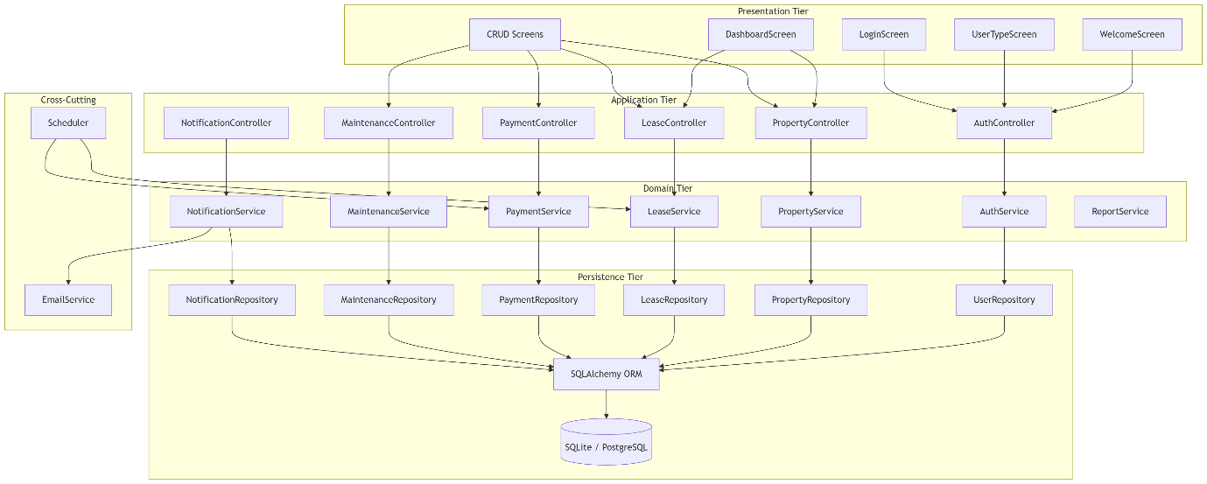

3.2 Use-Case Diagram
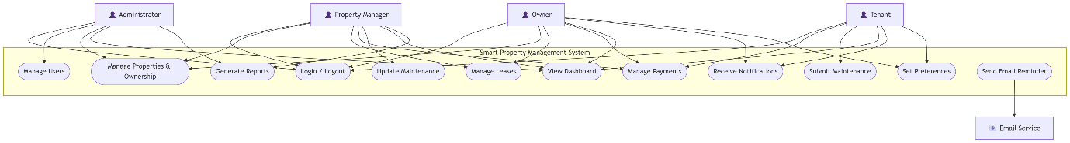

3.3 Domain Model (Class Diagram)
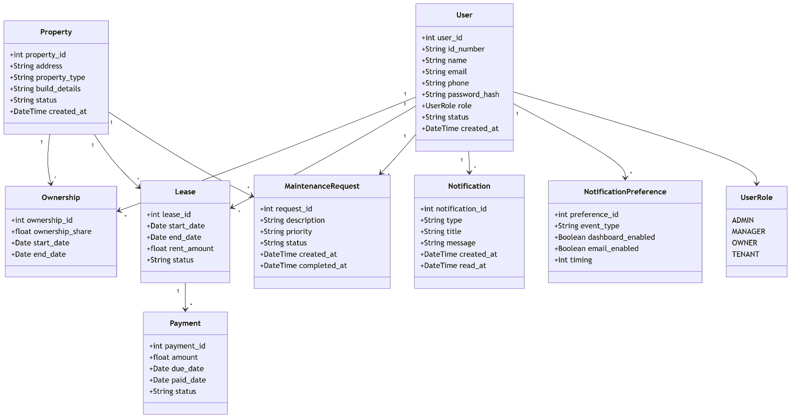

3.4 Database Design
3.4.1 Entity-Relationship Diagram
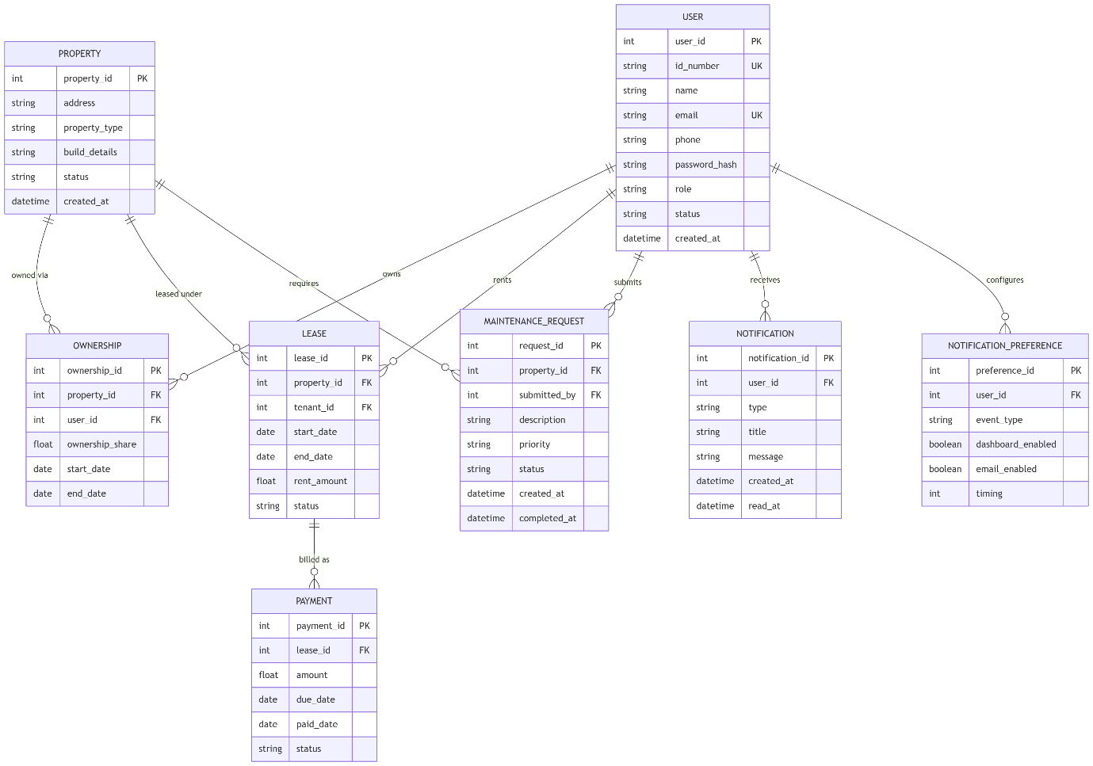

3.4.2 Relational Schema (Normalised to 3NF)
USERS (<u>user_id</u>, id_number, name, email, phone, password_hash, role, status, created_at)
PROPERTIES (<u>property_id</u>, address, property_type, build_details, status, created_at)
OWNERSHIPS (<u>ownership_id</u>, property_id†, user_id†, ownership_share, start_date, end_date)
LEASES (<u>lease_id</u>, property_id†, tenant_id†, start_date, end_date, rent_amount, status)
PAYMENTS (<u>payment_id</u>, lease_id†, amount, due_date, paid_date, status)
MAINTENANCE_REQUESTS (<u>request_id</u>, property_id†, submitted_by†, description, priority, status, created_at, completed_at)
NOTIFICATIONS (<u>notification_id</u>, user_id†, type, title, message, created_at, read_at)
NOTIFICATION_PREFERENCES (<u>preference_id</u>, user_id†, event_type, dashboard_enabled, email_enabled, timing)
*Unique. †Foreign key referencing the parent table.
Normalisation justification.
- 1NF: All attributes are atomic; no repeating groups. Co-ownership is modelled as multiple OWNERSHIP rows rather than a repeating attribute on PROPERTY.
- 2NF: Every non-key attribute depends on the whole primary key. In OWNERSHIPS the composite business key (property_id, user_id, start_date) has no partial dependencies.
- 3NF: No transitive dependencies. For example, property_address is not stored on LEASES — it is retrievable via property_id, avoiding update anomalies.

3.5 Interaction Design (Sequence Diagrams)
3.5.1 User Login
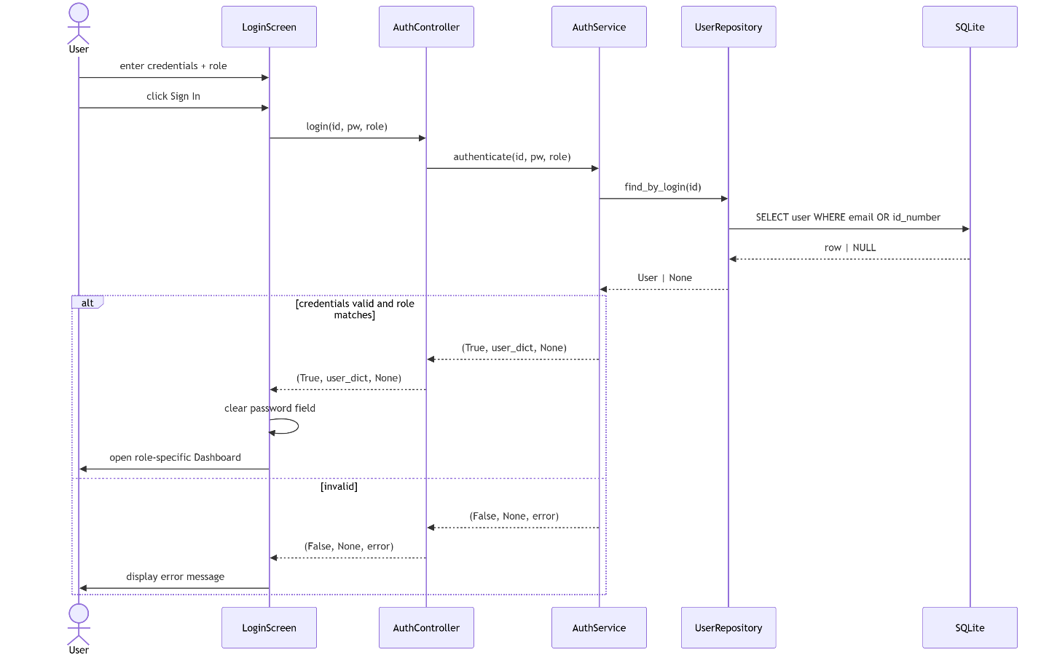
3.5.2 Add Property
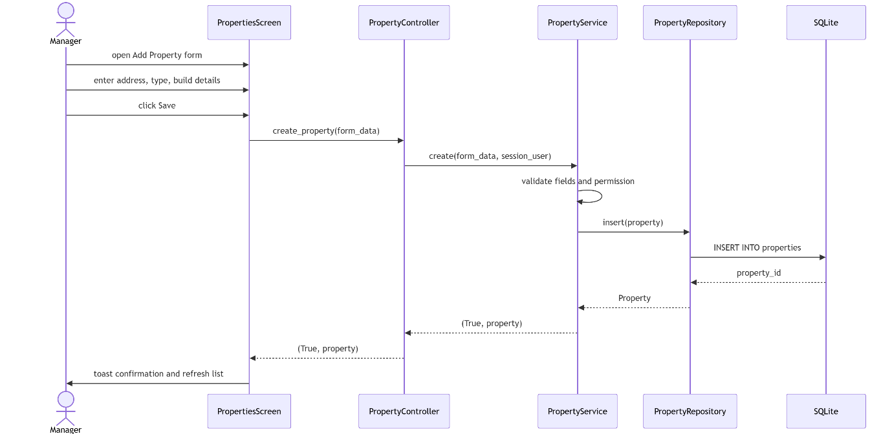

3.5.3 Automated Reminder Dispatch
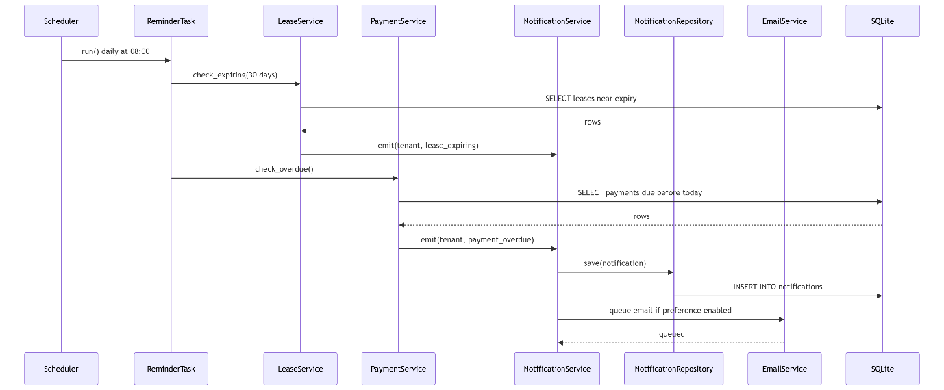

3.5.4 Maintenance Request Lifecycle
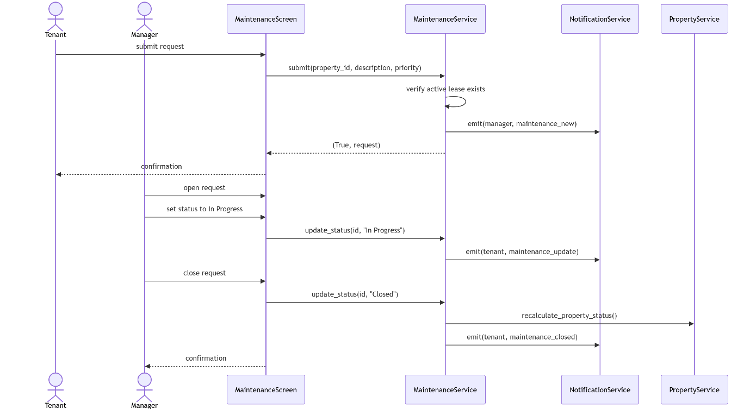

3.6 Behavioural Design (Activity Diagrams)
3.6.1 Login Activity
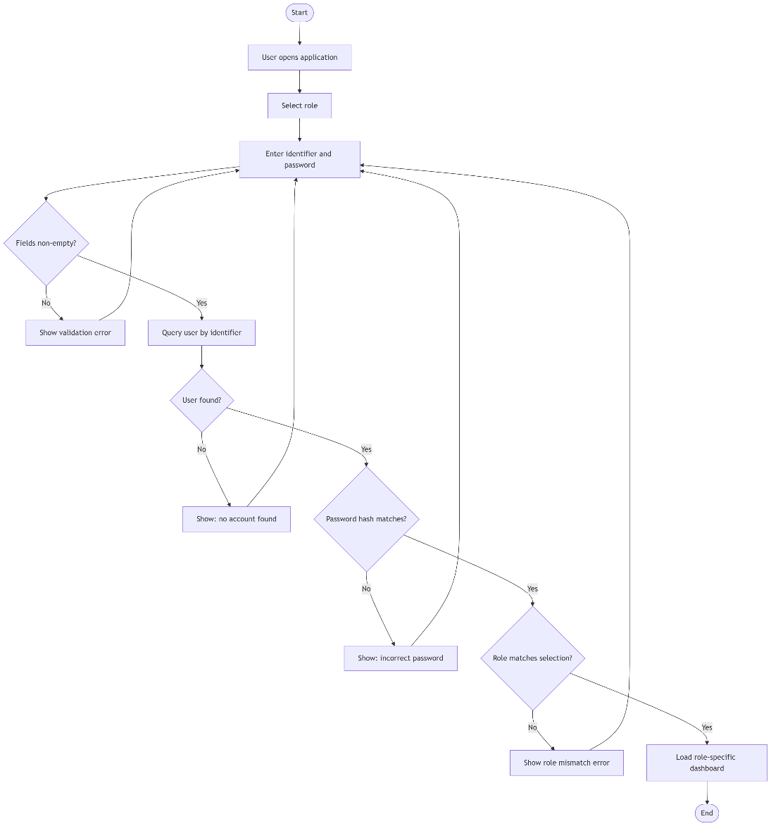

3.6.2 Property Registration Activity
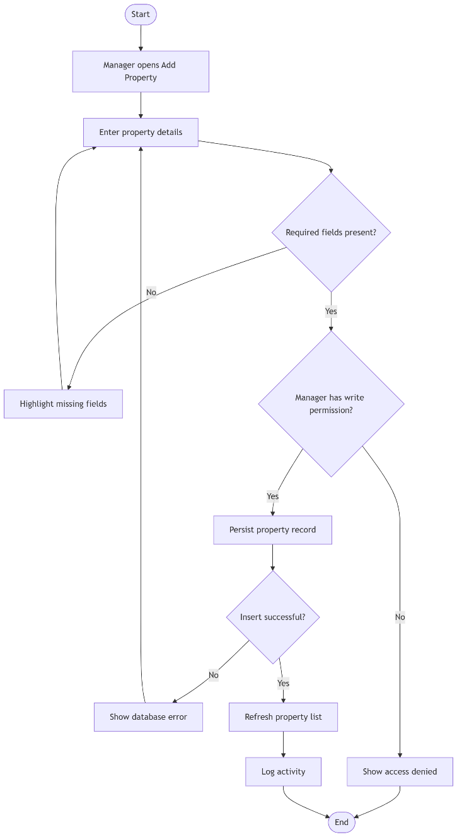

3.7 State Machine Design
3.7.1 Property Lifecycle
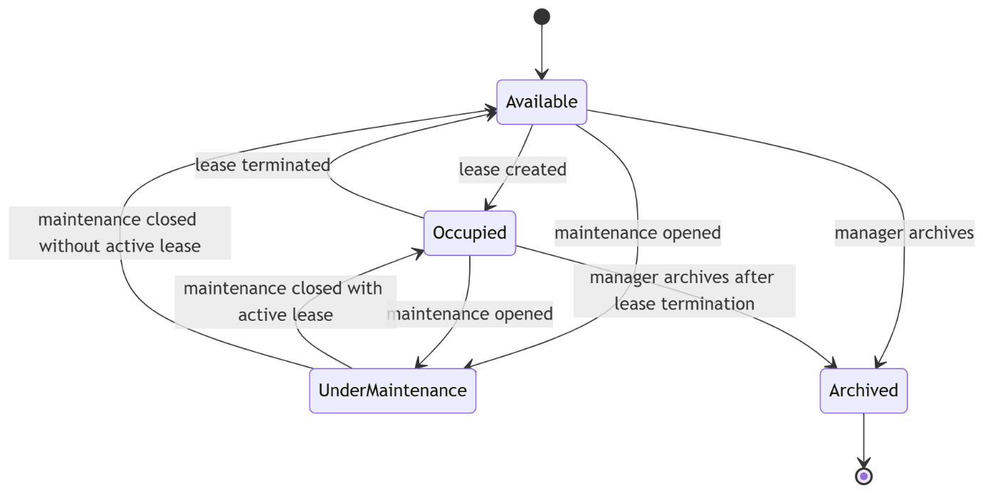
3.7.2 Lease Lifecycle
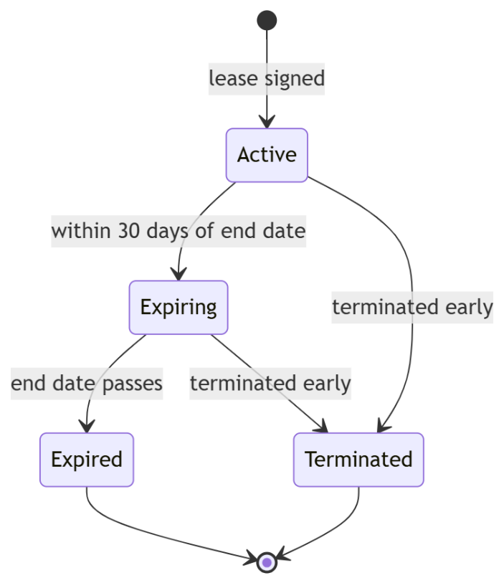

3.7.3 Payment Lifecycle
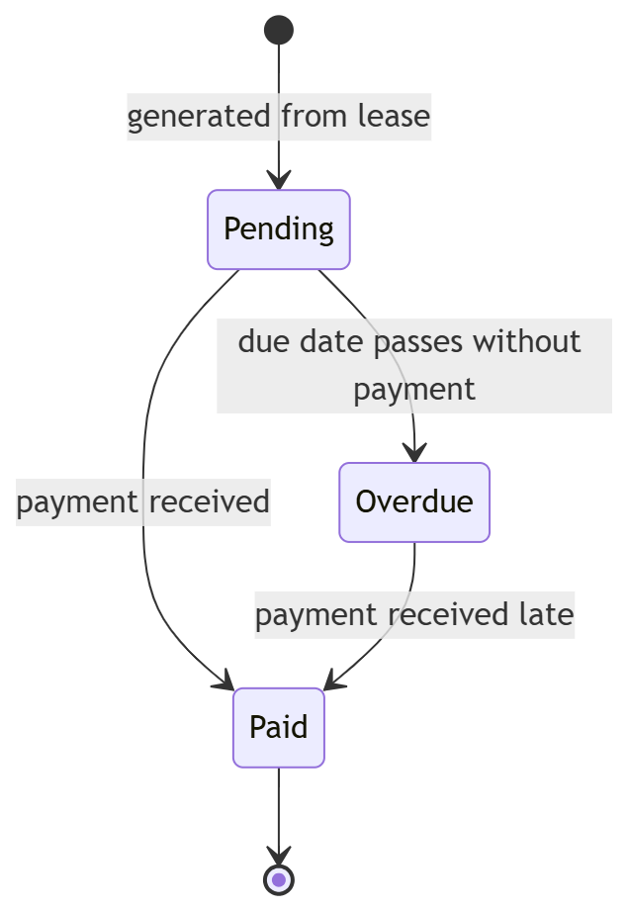

3.7.4 Maintenance Request Lifecycle
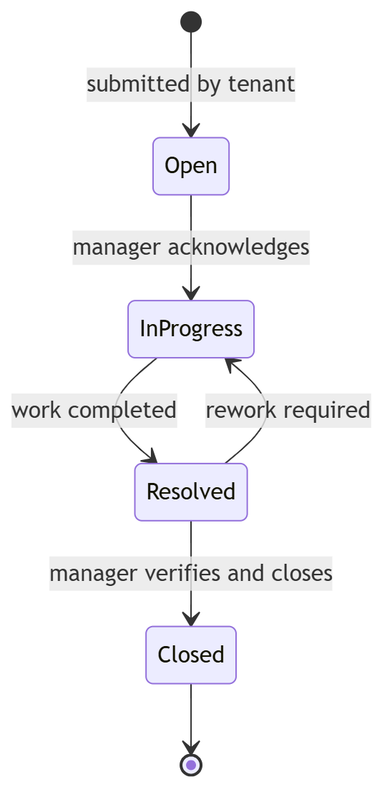

3.8 Deployment View
The system is delivered as a desktop application. Each user runs a local instance of the Python/PySide6 client. Data persistence is provided by an embedded SQLite database (development and demonstration) or a networked PostgreSQL instance (recommended production configuration). Outbound email is dispatched via an SMTP relay.
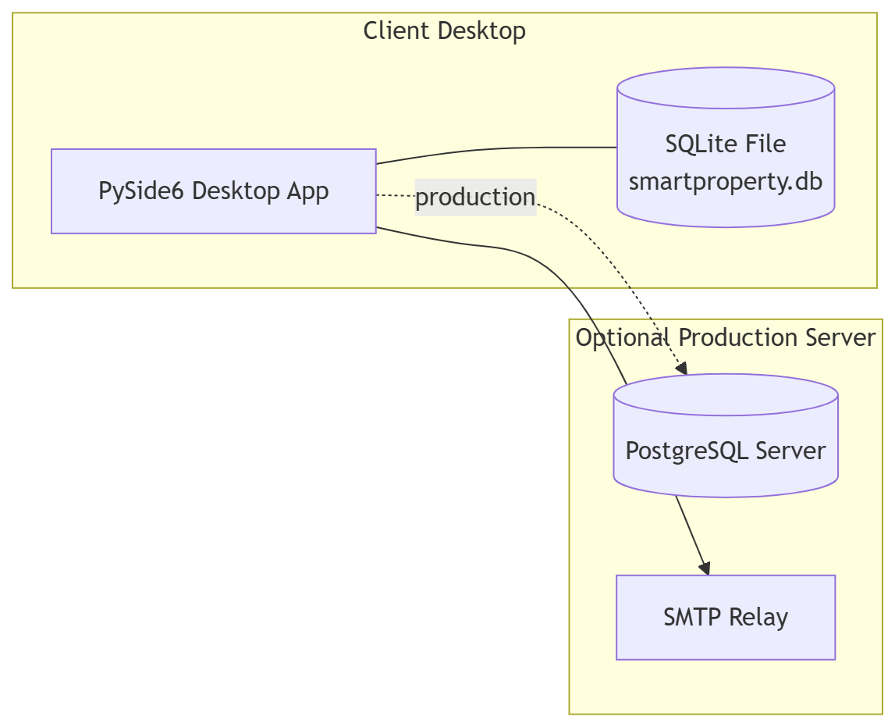
Deployment rationale.
- SQLite eliminates server dependency for the academic demonstration environment.
- SQLAlchemy's connection URL is the single point of change between the two configurations, so no application code is modified during the transition.
- Email is optional; the notification subsystem functions fully without it, satisfying the "graceful degradation" non-functional requirement.

3.9 User Interface Wireframes
Wireframes are provided as image files (Diagrams/wireframes/), rendered from the specifications below. Each screen is designed to be minimal, role-appropriate, and consistent with the layered architecture.
Screen | Purpose | Key elements
Welcome | Entry point | Product logo, tagline, Get Started call-to-action
User Type | Role selection | Four large role cards with icons
Login | Credential capture | Identifier, password with show/hide, error panel, role indicator
Dashboard | Role-aware overview | Statistics cards, quick action tiles, recent activity, notification bell
Properties | Property CRUD | Filterable table, Add/Edit modal, archive action
Leases | Lease management | Timeline view, expiry badge, terminate action
Payments | Payment tracking | Lease-grouped table, overdue highlights, mark-as-paid
Maintenance | Request handling | Kanban-style columns (Open / In Progress / Resolved / Closed)
Notifications | Notification centre | Unread-first list, mark-as-read, preference link
Reports | Report generation | Filter panel, preview pane, PDF export

4. Implementation

4.1 Technology Stack
Layer | Technology | Justification
Language | Python 3.14 | Rapid development, rich ecosystem, suitability for both UI and business logic
GUI | PySide6 (Qt 6) | Mature, cross-platform, native look-and-feel, LGPL
ORM | SQLAlchemy 2.0 | Declarative mapping, dialect independence, supports both SQLite and PostgreSQL
Database (dev) | SQLite | Zero-config, file-based, ideal for demonstration
Database (prod) | PostgreSQL | ACID guarantees, concurrent access, production-grade
Password hashing | bcrypt | Adaptive cost factor, resistant to rainbow tables
Charts (planned) | matplotlib | Embedded in Qt via FigureCanvasQTAgg
Reports (planned) | reportlab | Programmatic PDF generation
Scheduler (planned) | APScheduler | In-process cron-style task scheduling
Version control | Git + GitHub | Standard industry practice, off-machine backup

4.2 Project Structure
text
SmartPropertyManagementSystem/
├── main.py
├── requirements.txt
├── ui/ # Presentation tier
├── Controllers/ # Application tier
├── Services/ # Domain tier
├── Repositories/ # Persistence tier (data access)
├── Models/ # SQLAlchemy entity definitions
├── Database/ # Engine, session, schema, seeds
├── Diagrams/ # UML and wireframe assets
├── Documentation/ # Chapter documents and module design
├── Tests/ # Unit and integration tests
└── Assets/ # Icons, images, stylesheets

4.3 Core Algorithms
A1 — Credential Verification
text
procedure AUTHENTICATE(identifier, password, expected_role):
if identifier is empty or password is empty:
return FAILURE("Missing credentials")
user ← UserRepository.find_by_login(identifier)
if user is null:
return FAILURE("No account found")
if not bcrypt.verify(password, user.password_hash):
return FAILURE("Incorrect password")
if expected_role is set and user.role ≠ expected_role:
return FAILURE("Role mismatch")
return SUCCESS(user)
A2 — Overdue Payment Detection (invoked daily and on-read)
text
procedure CHECK_OVERDUE():
today ← current_date()
for each payment in PaymentRepository.find(status="Pending"):
if payment.due_date < today:
payment.status ← "Overdue"
PaymentRepository.update(payment)
NotificationService.emit(
user = payment.lease.tenant,
type = "payment_overdue",
message = format("Payment %d was due on %s",
payment.payment_id, payment.due_date)
)
A3 — Lease Expiry Detection
text
procedure CHECK_EXPIRING(threshold_days):
today ← current_date()
horizon ← today + threshold_days
for each lease in LeaseRepository.find(
status="Active", end_date between [today, horizon]):
NotificationService.emit(
user = lease.tenant,
type = "lease_expiring",
message = format("Lease %d expires on %s",
lease.lease_id, lease.end_date)
)
A4 — Ownership Share Validation
text
procedure ADD_OWNERSHIP(property_id, user_id, share, start, end):
if user.role ≠ OWNER:
return FAILURE("Only owners can be assigned ownership")
if end is set and start ≥ end:
return FAILURE("Invalid date range")
active_total ← OwnershipRepository.sum_active_shares(property_id)
if active_total + share > 1.0:
return FAILURE("Shares exceed 100%")
OwnershipRepository.insert(property_id, user_id, share, start, end)
return SUCCESS
A5 — Property Status Recalculation
text
procedure RECALCULATE_PROPERTY_STATUS(property_id):
if LeaseRepository.has_active_lease(property_id):
status ← "Occupied"
else if MaintenanceRepository.has_open_request(property_id):
status ← "Under Maintenance"
else:
status ← "Available"
PropertyRepository.set_status(property_id, status)

4.4 Integration Sequence
Implementation proceeds bottom-up to keep each tier testable in isolation:
- Persistence tier — models, schema, connection, seed data.
- Domain tier — services with unit tests for A1–A5.
- Application tier — controllers, delegating only.
- Presentation tier — screens, wired screen-by-screen.
- Cross-cutting — scheduler, notification dispatch, email.
- Integration tests covering login, property CRUD, and automated reminders end-to-end.
- Documentation and UML refresh against the implemented system.

